Phone: 091-484-2412300 E. Mail: cift@ciftmail.org
Fax: 091-484-2668212

ICAR-CENTRAL INSTITUTE OF FISHERIES TECHNOLOGY 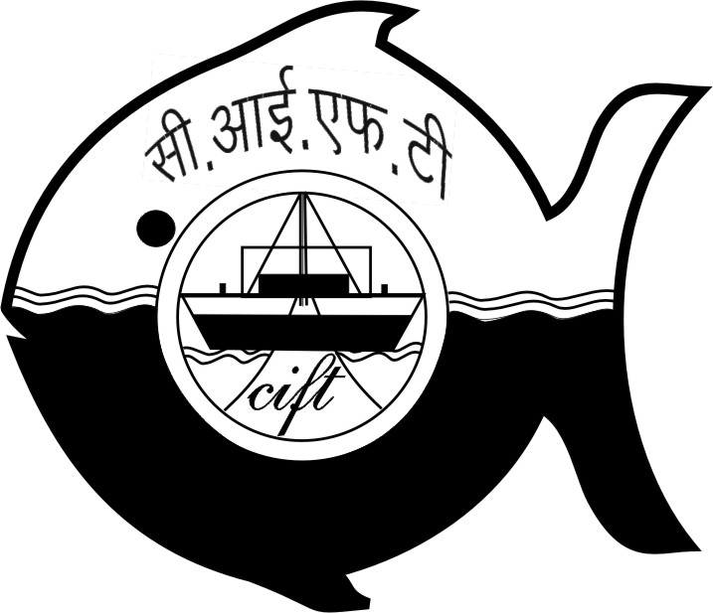
(Indian Council of Agricultural Research)
CIFT Junction, Matsyapuri P.O, Cochin - 682 029
------------------------------------------------------------------------------------------------------
AN ISO 17025:2005 CERTIFIED INSTITUTION
Swachh Pakhwara Activities at ICAR-CIFT, Cochin

16th October, 2016

ICAR-CIFT, Cochin initiated the Swachh Pakhwara celebrations from 16-31 October, 2016 in the Institute. Swachhta pledge was read by Dr. C.N. Ravishankar, Director, ICAR-CIFT and was taken by staff and residents at ICAR-CIFT residential quarters on 16th October, 2016. Director emphasized the need to keep the locality clean and responsibility of each towards attaining the goals of Swachh Bharat. A joint cleanliness drive was undertaken at the residential quarters of ICAR-CIFT where the staff and residents including children actively participated. The cleanliness drive was initiated at 10.30 a.m. and continued till 12.30 p.m.

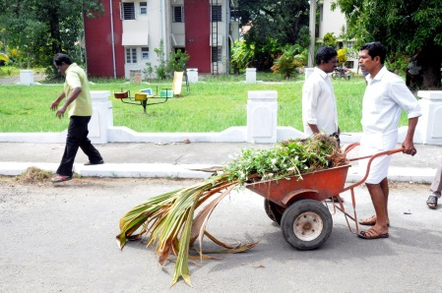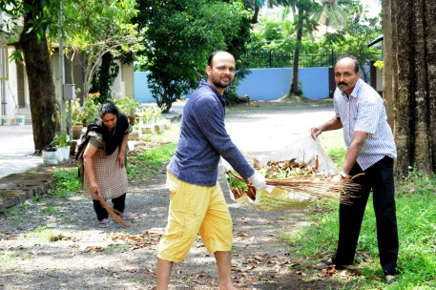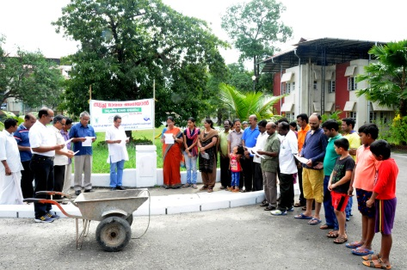

17th October, 2016

Swachhta pledge was again taken by all the staff of the Institute in the entrance lobby at 10.25 a.m. on 17th October, 2016 to be committed towards cleanliness and devote time to clean India which was followed by cleanliness drive in and around the institute premises by the staff. Director, ICAR-CIFT. Dr. C.N. Ravishankar joined hands with other staff in cleaning the Institute campus which continued up to 1.00 p.m. The scientists and staff actively participated in the programme.

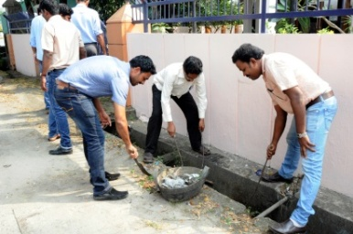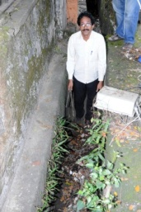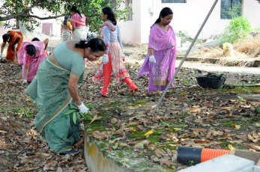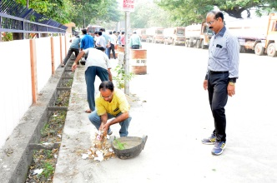

18th October, 2016

In continuation of the Swachh Pakhwara activities, intensive cleanliness drive was taken up at Division and Section level led by the concerned HODs/ Section Incharges with the participation of the Divisional staff. The programme included weeding out of unwanted records and other consumable office stationary. The Scientists and staff of the Institute participated in the cleanliness drive. The drive started at 2.30 p.m. and continued up to 4.30 p.m.

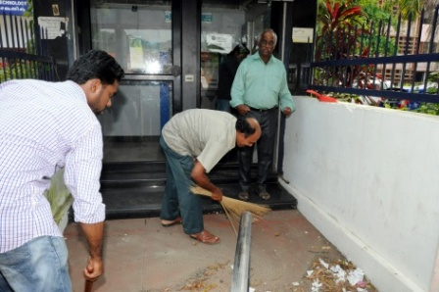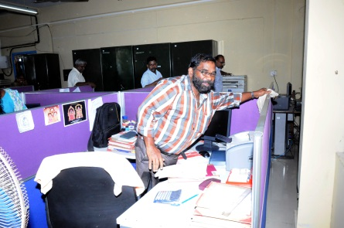

19th October, 2016

In continuation with the Swachh Pakhwara activities, various competitions were initiated in the adopted village of the Institute, Kannamaly. Students of Puthenthode Government Higher Secondary School participated in the programmes. On 19th October, 2016 a quiz competition was conducted for High School students by Dr. A.R.S. Menon, Chief Technical Officer. The students participated with great enthusiasm. Three teams were selected as the best and prizes will be awarded during the closing ceremony wherein the Director, ICAR-CIFT, Cochin will address the students.

